

**SMS DASHBOARD**

**SYSTEM OPERATION DOCUMENT**

MAB/GROUP IT/SOD/SMS Dashboard/1.2

##### Prepared by :

##### SMS Dashboard Support Team

##### Application Management Services (AMS)

##### Group IT

**ALL INFORMATION CONTAINED HEREIN IS RESTRICTED AND SHALL BE KEPT FOR INTERNAL USE ONLY**. None of this information shall be divulged to persons other than Malaysia AirlinesBerhad employees and contractors authorized by the nature of their duties to receive such information, or individuals or organisations authorised by Malaysia Airlines Berhad in accordance with existing policy regarding release of company information.

**INTENTIONALLY LEFT BLANK**

|  |  |  |  |
| --- | --- | --- | --- |
| Prepared By | : |  |  |
|  |  | Srikanth Kankara |  |
|  |  | SRAS Support Team |  |
|  |  | Application Management Services |  |
|  |  |  |  |
| Reviewed By | : |  |  |
|  |  | Suman Guduru |  |
|  |  | OST Tower Manager |  |
|  |  | Application Management Services |  |
|  | : |  |  |
|  |  | Noor Hafiza Bahruddin  IT - Service Delivery Management  Group IT |  |
|  |  |  |  |
|  |  |  |  |
| Approved By |  | Siti Hafsah Mohd Desa |  |
|  |  | Head IT Service Delivery Manager |  |
|  |  | Group IT |  |
|  |  |  |  |
|  |  |  |  |
|  |  |  |  |
|  |  |  |  |
|  |  |  |  |

**INTENTIONALLY LEFT BLANK**

**TABLE OF CONTENTS**

**Contents Page**

PART 1 - MANUAL ADMINISTRATION 1-1

1.1. RECORD OF REVISION 1-2

1.2. LIST OF EFFECTIVE PAGES 1-3

1.3. DISTRIBUTION LIST 1-4

1.4. LIST OF ABBREVIATIONS 1-4

1.5. CONDITION OF USE 1-5

1.6. CONTROL OF MANUAL 1-5

PART 2 - MANUAL BACKGROUND 2-1

2.1 INTRODUCTION 2-2

2.2 PURPOSE 2-2

2.3 SCOPE AND APPLICATION 2-2

2.4 TERMINOLOGY 2-2

2.5 REFERENCES 2-2

PART 3 – OVERVIEW OF BUSINESS PROCESS 3-1

3.1 OVERVIEW OF BUSINESS PROCESS 3-2

PART 4 - MANUAL CONTENT TITLE 4-1

4.1 Systems overview 4-2

4.1.1 System Architecture 4-2

4.1.2 Interfaces 4-3

4.1.2.1 User Interfaces 4-3

4.1.2.2 System Interfaces 4-14

4.1.3 Maintenance Period 4-16

4.1.4 Roles and Responsibilities 4-17

4.2 TECHNICAL SPECIFICATIONS 4-17

4.2.1 Hardware specifications 4-17

4.2.2 Software specifications 4-19

4.2.3 Communication / Network Specification 4-19

4.2.4 User and Equipment Locations 4-19

4.3 TECHNICAL OPERATIONS GUIDE 4-21

4.3.1 Backup and Recovery 4-21

4.3.2 Monitoring Tools 4-22

4.3.4 Report Management 4-22

4.3.5 Baseline Performance Information 4-22

4.4 MAINTENANCE AND SUPPORT 4-22

4.4.1 Problem Logging 4-23

4.4.2 Problem Categorization and Escalation MATRIX 4-23

4.4.3 Application / Technical Support 4-24

4.5 ACCESSING THE APPLICATION 4-24

4.6 CONTRACT MANAGEMENT 4-24

4.7 HANDOVER ITEMS 4-24

4.8 INFORMATION SECURITY 4-25

4.8.1 Audit and Compliance Requirements 4-25

4.8.2 Password Policy Compliance 4-25

4.9 DOCUMENTATION AND REFERENCES 4-26

**APPENDIX**

PART 1- MANUAL ADMINISTRATION

# RECORD OF REVISION

| **No.** | **Description Of Changes** | **Issue No.** | **Rev. No.** | **Author** | **Effective Date** |
| --- | --- | --- | --- | --- | --- |
| 1 | Original | 1 | 0 | Srikanth Reddy Kankara | 01-Jul-20 |
| 2 | Change Email template for SMS Dashboard Application. | 1 | 1 | Srikanth Reddy Kankara | 20-Jul-20 |
| 3 | MYSQL Migration from mysql-connector-java-5.1.26 to mysql-connector-java-8.0.20 | 1 | 2 | Srikanth Reddy Kankara | 23-July-20 |
|  |  |  |  |  |  |
|  |  |  |  |  |  |
|  |  |  |  |  |  |
|  |  |  |  |  |  |
|  |  |  |  |  |  |
|  |  |  |  |  |  |
|  |  |  |  |  |  |
|  |  |  |  |  |  |
|  |  |  |  |  |  |
|  |  |  |  |  |  |

# 

# LIST OF EFFECTIVE PAGES

|  |  |  |  |  |  |  |  |  |  |  |
| --- | --- | --- | --- | --- | --- | --- | --- | --- | --- | --- |
| **Part** | **Page** | **Issue No.** | **Revision No.** | **Effective Date** |  | **Part** | **Page** | **Issue No.** | **Revision No.** | **Effective Date** |
| 1 | 1-1 | 1 | 0 | 01-07-20 |  |  | 4-12 | 1 | 0 | 01-07-20 |
|  | 1-2 | 1 | 0 | 01-07-20 |  |  | 4-13 | 1 | 0 | 01-07-20 |
|  | 1-3 | 1 | 0 | 01-07-20 |  |  | 4-14 | 1 | 0 | 01-07-20 |
|  | 1-4 | 1 | 0 | 01-07-20 |  |  | 4-15 | 1 | 0 | 01-07-20 |
|  | 1-5 | 1 | 0 | 01-07-20 |  |  | 4-16 | 1 | 0 | 01-07-20 |
|  | 1-6 | 1 | 0 | 01-07-20 |  |  | 4-17 | 1 | 0 | 01-07-20 |
| 2 | 2-1 | 1 | 0 | 01-07-20 |  |  | 4-18 | 1 | 0 | 01-07-20 |
|  | 2-2 | 1 | 0 | 01-07-20 |  |  | 4-19 | 1 | 0 | 01-07-20 |
| 3 | 3-1 | 1 | 0 | 01-07-20 |  |  | 4-20 | 1 | 0 | 01-07-20 |
|  | 3-2 | 1 | 0 | 01-07-20 |  |  | 4-21 | 1 | 0 | 01-07-20 |
|  | 3-3 | 1 | 0 | 01-07-20 |  |  | 4-22 | 1 | 0 | 01-07-20 |
|  | 3-4 | 1 | 0 | 01-07-20 |  |  | 4-23 | 1 | 0 | 01-07-20 |
| 4 | 4-1 | 1 | 0 | 01-07-20 |  |  | 4-24 | 1 | 0 | 01-07-20 |
|  | 4-2 | 1 | 0 | 01-07-20 |  |  | 4-25 | 1 | 0 | 01-07-20 |
|  | 4-3 | 1 | 0 | 01-07-20 |  |  | 4-26 | 1 | 0 | 01-07-20 |
|  | 4-4 | 1 | 0 | 01-07-20 |  |  |  |  |  |  |
|  | 4-5 | 1 | 0 | 01-07-20 |  |  |  |  |  |  |
|  | 4-6 | 1 | 0 | 01-07-20 |  |  |  |  |  |  |
|  | 4-7 | 1 | 0 | 01-07-20 |  |  |  |  |  |  |
|  | 4-8 | 1 | 0 | 01-07-20 |  |  |  |  |  |  |
|  | 4-9 | 1 | 0 | 01-07-20 |  |  |  |  |  |  |
|  | 4-10 | 1 | 0 | 01-07-20 |  |  |  |  |  |  |
|  | 4-11 | 1 | 0 | 01-07-20 |  |  |  |  |  |  |

# DISTRIBUTION LIST

|  |  |  |
| --- | --- | --- |
| **NAME** | **DEPT / AREA** | **DESIGNATION** |
| Azrul Azwar Muhamad | GTO – Information Technology | System Owner |
| Siti Hafsah Mohd Desa | Group IT | Head IT SDM |
| Wan Mohd Husni Wan Hussein | AMS | AMS SDM |

Table 1: Distribution List

# LIST OF ABBREVIATIONS

The following are the abbreviations used for the purpose of simplification

|  |  |
| --- | --- |
| **Abbreviation** | **Denote** |
| AMS | Application Maintenance & Support |
| SRAS | Small Rapid Application System |
| SOD | System Operating Document |
| LDAP | Light Weight Directory Access Protocol |
| AD | Active Directory |
| MAB | Malaysia Airlines Berhad |

Table 2: List of Abbreviations

# CONDITION OF USE

* + 1. This manual is the property of Malaysia Airlines Berhad.
    2. All copies assigned to individual position(s), section(s) or station(s) is on loan basis. If, for any reason, the position(s), section(s) or station(s) is abolished from the company organization, the respective copy(ies) of the manual must be returned to Head IT Service Delivery Manager.
    3. In the event where the title of the position or section is changed, the department concerned shall inform Head IT Service Delivery Manager promptly.
    4. The content of this manual shall not be copied, or communicated in part or as a whole, to any person not employed by the Company without the express written consent of the Head IT Service Delivery Manager.
    5. It is the responsibility of the holder to ensure that his copy is updated to the latest amendments and is in good state of condition.

# CONTROL OF MANUAL

* + 1. The contents of this manual shall not be deleted, added, or altered in any way without the approval of the Head IT Service Delivery Manager.
    2. Any page which carries an amendment must bear the new revision date. Any line which is amended shall be highlighted by a revision bar (i.e. dark vertical line) drawn close to the amended text on the outside border of the document.
    3. A transmittal letter must accompany the amended pages to advise the holders how to effect the amendment to their copies.
    4. Holders shall notify this department in writing for loss of manual and to obtain a replacement copy. Head IT Service Delivery Manager shall ensure that this manual reviewed at least once a year and effect necessary amendments as and when necessary. Should any person(s) envisage improvements needed for the contents of this manual, the person should direct the request to the Head IT Service Delivery Manager.

PART 2- MANUAL BACKGROUND

# INTRODUCTION

This is the SMS Dashboard SOD, hereinafter referred to as “the Policy” provides comprehensive operating procedures within the scope and application herein defined in Part 2 Section 3.0 for Malaysia Airlines Berhad (MAB).

# PURPOSE

The objective of this document is to provide relevant information required to operate and support SMS Dashboard.

# SCOPE AND APPLICATION

This SOD covers all information required to operate and support the solution in production.

This SOD does not include the following:

* Application maintenance for the sub-systems interfaced by the core system.

# TERMINOLOGY

Please refer to the below terminology used in this document

|  |  |  |
| --- | --- | --- |
| 1 | App | Application |
| 2 | DB | Database |
| 3 | DSL | Domain Specific Language |
| 4 | AD | Active Directory |
| 5 | OS | Operating System |
| 6 | SRAS | Small Rapid Application System |

Table 3: Terminology

# REFERENCES

This SOD is prepared with reference to the below supporting documents.

| **No** | **Document** | **Description** |
| --- | --- | --- |
|  |  |  |

Table 4: References

PART 3–OVERVIEW OF BUSINESS PROCESS

# OVERVIEW OF BUSINESS PROCESS

3.1.1 SMS Dashboard portal captures all the text messages sent outside of MAB to the vendor through EAI. So, basically one copy of data is passed to this application to store it in the database. The purpose of this portal is to store and view all these messages and their status. A batch job is configured that collects this information and provides the success and failure count for past 24hrs through email.

MYSQL Migration from mysql-connector-java-5.1.26 to mysql-connector-java-8.0.20 was done for the application under CHG0018708 change request.

3.1.2 SMS Dashboard menu;

* Home
* Charts
* Logout

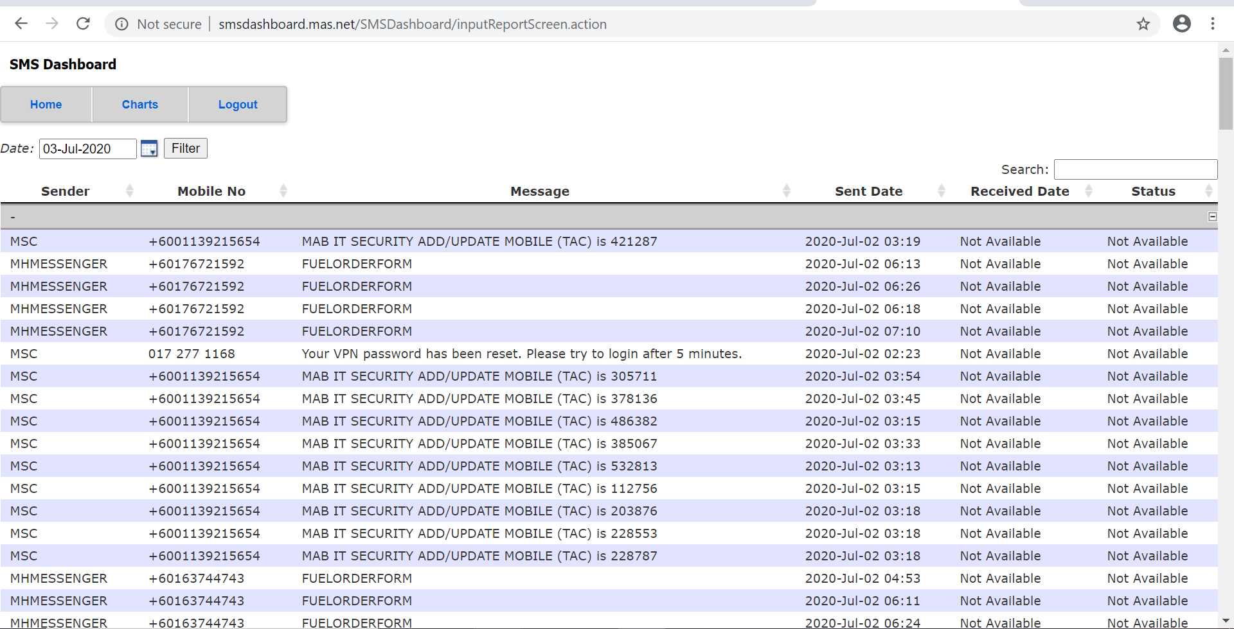

*Figure 1: SMS Dashboard*

PART 4- MANUAL CONTENT TITLE

**4.1** **Systems overview**

* The SMS Dashboard is a web-based applications developed using Open Source Software (OSS) such as Linux, Apache, MySQL and Java.
* This application captures all the text messages that are sent outside of MAB to the vendors in the EAI side.
* So basically, one copy of the data is passed to SMS Dashboard application and that data is stored into the database.
* The main purpose of this application is to store the messages which are going away from MAB and view all these messages with their status in tabular format in this application.
* A batch job is configured that collects the information and provides the success and failure count for past 24hrs through email. This batch job is scheduled at 1:00 AM MYT daily.
* The email triggering is automated, it is just that we retrieve the data from the database and present it in excel format.

## 4.1.1 System Architecture

* This application captures all the text messages that are sent outside of MAB to the vendors in the EAI side.
* A copy of message data sent outside of MAB through EAI is stored in SMS Dashboard database. The purpose of this application is to receive the data using the services and store it into the database and then view this data using UI.

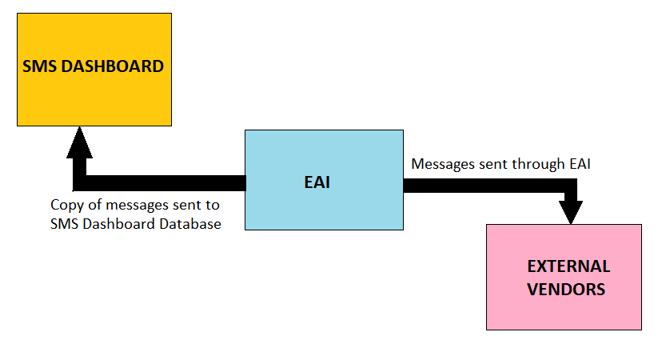

Figure 2: Message flow diagram

## 4.1.2 Interfaces

### 4.1.2.1 User Interfaces

SMS Dashboard System will have the following features:

1. Login
2. Home
3. Charts

#### 4.1.2.1.1 Login

Any user can login into SMS Dashboard System with their staff Id and password provided their staff id is mentioned in TCM_USER_PROFILE table prior to using this system. Using the following URL can launch the application.

http://smsdashboard.mas.net

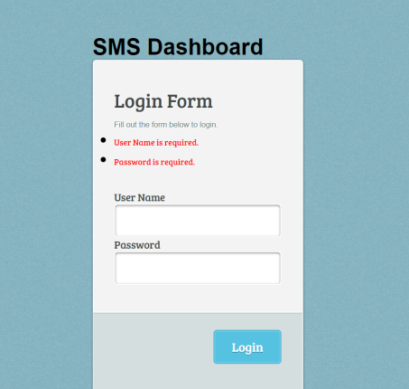

Figure 3: Login

#### 4.1.2.1.2 Home

#### After successfully validating the user he is redirected to Home page of SMS Dashboard system. This page provides the data from the database in tabular format depending on the date selected in the filter. It provides Sender Details, Mobile Numbers, Messages, Sent Date, Received Date and Status of all the messages sent outside of MAB through EAI.



Figure 4: Home

**4.1.2.1.3 Charts**

SMS Dashboard application also provides with graphical representation for Status Vs Count from where we can get the graphical view for any selected date. It also allows to select multiple dates at a time and provides the graphical view.

**4.1.2.2** **System Interfaces**

System interface diagram for SMS Dashboard Application 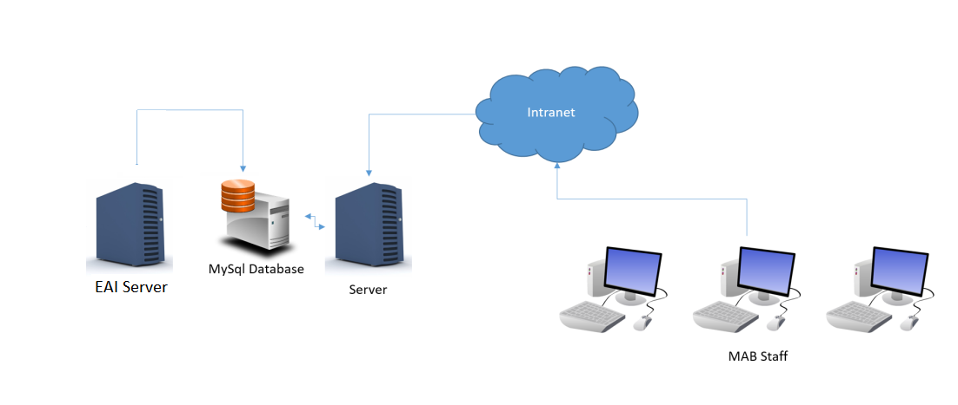

*Figure 6: System Interface Diagram*

## 4.1.3 Maintenance Period

The maintenance period details are as below.

|  |  |  |
| --- | --- | --- |
|  | **Start Date** | **End Date** |
| Maintenance and Support (SRAS Application) | *01/05/2019* | *31/04/2024* |

Table 5: Maintenance Period

## 4.1.4 Roles and Responsibilities

Below table contains the roles and responsibilities of support team.

|  |  |  |  |  |  |
| --- | --- | --- | --- | --- | --- |
| **Role** | **Responsibility** | **Name** | **Designation** | **Company / Department** | **Contact (Phone & Email)** |
| MAB Group IT Infrastructure Group  (Midrange Team) | * Responsible for maintaining BID infrastructure. * Responsible backup and restore activity for BID * Responsible for maintaining web server. * Responsible for troubleshooting infrastructure related problems. | Rajendra Prasad | Unix Admin | TCS/MIDRANGE | ext_rajendra.prasad@malaysiaairlines.com  GD_TCSMidrange |
| MAB Group IT Infrastructure Group  (DB Team) | * Responsible for maintaining database. * Responsible for troubleshooting database related problems. * Creation of new database | Mayur Dhawan | Database Admin | TCS/DBA | ext_mayur.dhawan@malaysiaairlines.com  GD_TCSDatabase |
| MAB Helpdesk | * As single point of contact to coordinate when BID problems occurred. * Responsible to coordinate problem reporting to the respective parties | - | - | - | helpdesk@malaysiaairlines.com  +6 03 7863 2020 |
| Application Support (AMS) | * Responsible for maintaining BID application as second level support. * Assess change request for BID. * Develop and unit testing new BID request * Coordinate UAT with BU. * Work with Infra to deploy new BID changes. | Srikanth Reddy Kankara | IT Assistant Consultant | ATOS AMS | ext_srikanth.kankara@malaysiaairlines.com  GD_AMS_SRAS  +91 9986373560 |

Table 6: Roles and Responsibilities

*\*Note: Proper handover must be performed if there is any change to the above roles and the matrix will be updated accordingly.*

# 4.2 TECHNICAL SPECIFICATIONS

## 4.2.1 Hardware specifications

Hardware specifications are given in below table

|  |  |  |
| --- | --- | --- |
| **No** | **Category** | **Configuration** |
| 1 | Testing Server IP :  10.221.12.29  (3srasjavaapp1.mas.net) | Running in VMware System  2x vCPU  3.5 GB Ram Memory  100G Harddisk  Red Hat Enterprise Linux AS RHEL 7.2 |
| 2 | Testing DB Server IP:  10.221.14.26  (3srasjavadb1.mas.net:3036) | Running in VMware System  2x vCPU  3.5 GB Ram Memory  100G Harddisk  Red Hat Enterprise Linux AS RHEL 7.2 |
| 3 | Production Server IP:  10.221.55.10  (1srasjavaapp1.mas.net) | Running in VMware System  2x vCPU  3.5 GB Ram Memory  100G Harddisk  Red Hat Enterprise Linux AS RHEL 7.2 |
| 4 | Production DB Server IP:  10.221.6.22  (1srasjavadb1.mas.net:3036) | Running in VMware System  2x vCPU  3.5 GB Ram Memory  100G Harddisk  Red Hat Enterprise Linux AS RHEL 7.2 |

*Table 7: Hardware Specifications*

## 4.2.2 Software specifications

Below is the list of software required for SMS Dashboard development, support & maintenance activity.

|  |  |  |
| --- | --- | --- |
| **S.No** | **Software** | **Specifications** |
| 1 | App Server | Apache Tomcat 8.5.9 |
| 2 | Monitoring application | SCOM |
| 3 | Programming Language – UI | Java, Web services & JSP |
| 4 | Programming Language – DB | SQL |
| 5 | Front-end | IE 8+, Firefox 5+, Chrome 18+, Safari 5+, Opera 9+ |
| 6 | Database | MySQL 8.0.20 |

Table 8: Software Specifications

## 4.2.3 Communication / Network Specification

The server is accessible through TCP/IP LAN/WAN connection. Users using their desktop browser can access the application over the LAN connection to the server. The current supported browser is Internet Explorer (IE) ver. 11

|  |  |  |
| --- | --- | --- |
| *No* | ***Category*** | ***Configuration*** |
| 1 | Web Port 8080 | 3srasjavaapp1.mas.net |
| 2 | Web Port 8080 | 1srasjavaapp1.mas.net |
| 3 | Web Port 3036 (DB) | 3srasjavadb1.mas.net |
| 4 | Web Port 3036 (DB) | 1srasjavadb1.mas.net |

*Table 9: Communication / network specification listing*

## 4.2.4 User and Equipment Locations

Users need an appropriate browser to access the application. Supported browsers are listed in Section 4.2.

## 4.2.5 File Management

### 4.2.5.1 Libraries and files

**N/A**

### 4.2.5.2 DBMS setup

SMS Dashboard uses MySQL as the DBMS.

# 4.3 TECHNICALOPERATIONSGUIDE

Tomcat needs to be restarted when it goes down.

Database needs to be restarted when it goes down

## 4.3.1 Backup and Recovery

**N/A**

## 4.3.2 Monitoring Tools

## SMS Dashboard servers will be monitoring by SCOM Monitoring System.

## 4.3.4 Report Management

## N/A

## 4.3.5 Baseline Performance Information

SMS Dashboard is classified as a Business Criticality Definition (BCD) level 4 applications. There is no Disaster Recovery capability for this application. In the event of disaster recovery, the application will not be available. To mitigate the risk that can impact the business, user of this application should have a back-up plan in the event of the application or system unavailability.

# 4.4 MAINTENANCE AND SUPPORT

The maintenance SMS Dashboard operations team as listed below

|  |  |  |
| --- | --- | --- |
|  | ***Type of Support*** | ***Contact Details*** |
| 1 | IT Helpdesk  (1st Level Support) | (603) 7840-2020, 1-800-88-1173  helpdesk@malayasiaairlines.com |
| 2 | Group IT Operations  (2nd Level Support) | System Administrator (Midrange)  [GD_TCSMidrange@malaysiaairlines.com](mailto:GD_TCSMidrange@malaysiaairlines.com),  DB Administrator  [GD_TCSDatabase@malaysiaairlines.com](mailto:GD_TCSDatabase@malaysiaairlines.com)  Network Administrator  [GD_TCSNetwork@malaysiaairlines.com](mailto:GD_TCSNetwork@malaysiaairlines.com)  SMTP/FTP Administrator  [GD_TCSNetwork@malaysiaairlines.com](mailto:GD_TCSNetwork@malaysiaairlines.com)  For the actual support during the operation period, refer to MAB Helpdesk for up-to date Infra support personnel who are on call.  Application Support  [gd_ams_sras@malaysiaairlines.com](mailto:gd_tcs_sras@malaysiaairlines.com) |

Table 10: Maintenance and support listing

## 4.4.1 Problem Logging

The Help Desk personnel should ask the users:

For a screenshot of the error/issue that they are facing

For the steps that need to be performed to recreate the error/issue

To check the same steps to recreate the error/issue on another machine

To check if others are also facing the same error/issue.

## 4.4.2 Problem Categorization and Escalation MATRIX

Helpdesk will analyze the problem and assign a ticket number and a severity level which is mutually agreed by the user based on the Group IT SLA.

For all non-application related problems, Helpdesk will channel the problem ticket to the respective support from Infra- Midrange, Infra-DBA, Infra-Network or Desktop support for PC / browser problems.

## 4.4.3 APPLICATION / Technical Support

Refer to section 4.1.4

# 4.5 Accessing the Application

Users can access the application by visiting http://SMS Dashboard.mas.net/SMS Dashboard in their browsers. The compatible browsers are given in section 4.3.

# 4.6 CONTRACT MANAGEMENT

|  |  |  |
| --- | --- | --- |
| SI No | **Contract** | **Parties** |
| 1. | Service contract for AMS support services | Signed between MAB and ATOS |

Table 11: Contract management listing

*Copies of the contract / agreement are kept by (Name) and can be read at (directory).*

# 4.7 HANDOVER ITEMS

1. System Operating Document (SOD)

# 4.8 INFORMATION SECURITY

## 4.8.1 Audit and Compliance Requirements

Audit & compliance requirements are given below

|  |  |  |
| --- | --- | --- |
| **Activity** | **Frequency** | **Responsible Party** |
| Perform ID review every quarter and submit result to IRS  [Req: ISO 27001, PCI-DSS] | Quarterly | ID Admin |
| Update user access matrix and submit to IRS  [Req: ISO 27001, PCI-DSS] | Yearly | System Owner |
| Install Critical Security Patches for the application and submit report to IRS  [Req: ISO 27001, PCI-DSS] | Quarterly | System Owner |
| Performed Backup restoration  [Req: ISO 27001, PCI-DSS] | Yearly | System Owner |
| Review & update security documentation and submit to IRS:   * Super/privilege IDs and access * Security Controls Setting * Audit Logs setting * System bypass * List of connections and integration * List of used ports * Data encryption setting * Application/system schematic diagram   [Req: ISO 27001] | Yearly | System Owner |

Table 12: Audit and Compliance Requirements

## 4.8.2 Password Policy Compliance

Application follows the below password policy compliance

|  |  |  |  |  |
| --- | --- | --- | --- | --- |
|  | **Password Policy Requirements** | **Yes** | **No** | **Remarks** |
|  | Password length at least 8 characters (minimum) | Yes |  |  |
|  | Alphanumeric | Yes |  |  |
|  | Change temporary password at first logon | Yes |  |  |
|  | Password expiry = 90 days (maximum) | Yes |  |  |
|  | Password reuse generation = 5 (minimum) | Yes |  |  |
|  | Account lock out after 5 failed login attempts | Yes |  |  |
|  | Application shall disconnect or suspend inactive sessions= 15 Minutes | Yes |  |  |
|  | Wrong password shall be recorded in an audit log | Yes |  |  |

Table 13: Password Policy Compliance

# 4.8 DOCUMENTATION AND REFERENCES

Following are other documents related to the application

|  | **Document** | **Location and reference** |
| --- | --- | --- |
| 1 | System Operation Document  (soft copy of this document) |  |

Table 14: Document and References

## APPENDIX

|  |  |  |
| --- | --- | --- |
| **Ref. No** | **Description** | **Implementation Date** |
| CHG0018582 | Change Email template for SMS Dashboard Application. | 20-Jul-20 |
| CHG0018708 | MYSQL Migration from mysql-connector-java-5.1.26 to mysql-connector-java-8.0.20 | 23-July-20 |

**PATCH MANAGEMENT REPORT**

Application : ______________________________________________________

Owner **: ______________________________________________________**

|  |  |
| --- | --- |
| **Date** | **Patch / Service Pack Applied** |
|  |  |
|  |  |
|  |  |
|  |  |

**Prepared By: Approved By:**

**.................................................... ....................................................**

**System Admin System Owner**

**BACKUP RESTORATION REPORT**

Application : ______________________________________________________

Owner **: ______________________________________________________**

|  |  |
| --- | --- |
| **Date** | **Status of Restoration** |
|  |  |
|  |  |
|  |  |
|  |  |

**Prepared By: Approved By:**

**.................................................... ....................................................**

**Backup Admin System Owner**

**NON COMPLIANCE REPORT**

Application : ______________________________________________________

Owner **: ______________________________________________________**

|  |  |  |
| --- | --- | --- |
| **Date** | **Reference Number** | **Description** |
|  |  |  |
|  |  |  |
|  |  |  |
|  |  |  |

**Prepared By: Approved By:**

**.................................................... ....................................................**

**System Admin System Owner**

**END OF DOCUMENT**